Application Settings:

The application icon should be available on the desktop or within the program folder.



The user interface is simply a few text boxes and save/process buttons.

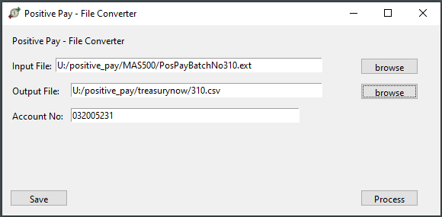

The settings visible in the entry fields are stored in the user’s registry settings.

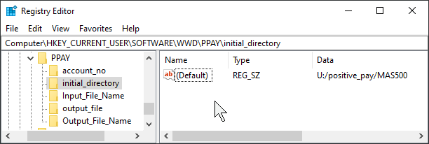

If you wish to remove the application, remove as usual, and then If needed, please delete the root key …\WWD\PPAY